Calculator App Documentation

Developed by: Ajna Sukraj-Ramkissoon

Date: 23 May 2025

# Overview

A calculator to perform basic math operations using OOP principles. Developed in C# using .NET 8 as a windows application.

# Features

* Basic math operations: addition, subtraction, multiplication, division
* Operator chaining: Can choose multiple operations without clearing
* Error handling: Division by zero is handled with an error message
* OOP Design: includes inheritance, polymorphism, and encapsulation
* Clear button to reset the calculator

# How to Install and Use

1. In the Application Folder, Run the Calculator.exe
2. Input numbers using buttons.
3. Select an operator (+, -, *, /).
4. Continue chaining operations or press "=" to get the result.
5. Use "Clear" to reset the calculator.

The solution can be opened from: \Orderwise\Calculator\Calculator.sln"

# Known Issues

* BUG: Common behaviour in WinForms problem where the last-focused button gets "activated" when you press Enter – therefore sometimes a different button is selected instead of the EQUALS button as ENTER.
* Could be extended to support correct order of maths operations
* UI can be enhanced.
* Store in memory features to be added

# Unit Test Results

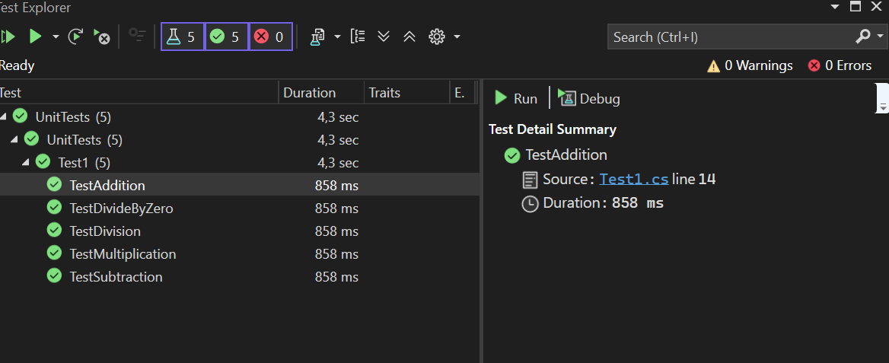

# Contact

For questions or feedback, reach out to:

Ajna Sukraj-Ramkissoon

0814868063

sukraj.ajna@gmail.com